I. 1. What is the name of this city?
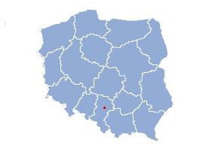
Czestochowa

I. 2. What is the name of the President of Poland who died in a plane crash in 2010?
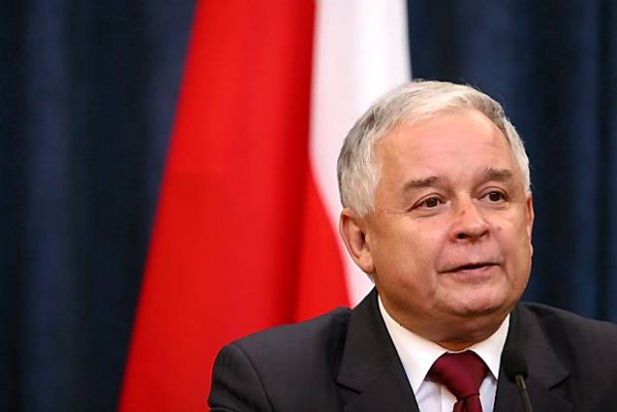
Lech Kaczyński

I. 3. When is the National Independence Day of Poland?

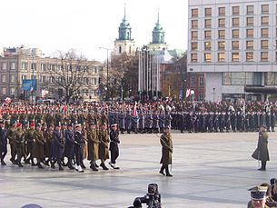
11th of November

I. 4. How many countries are in the European Union?
28

I. 5. Which country is the most populated in Africa?
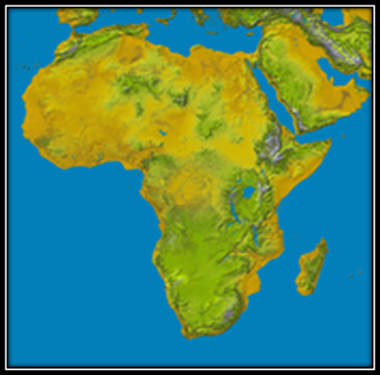
Nigeria

I. 6. Who is this politician?
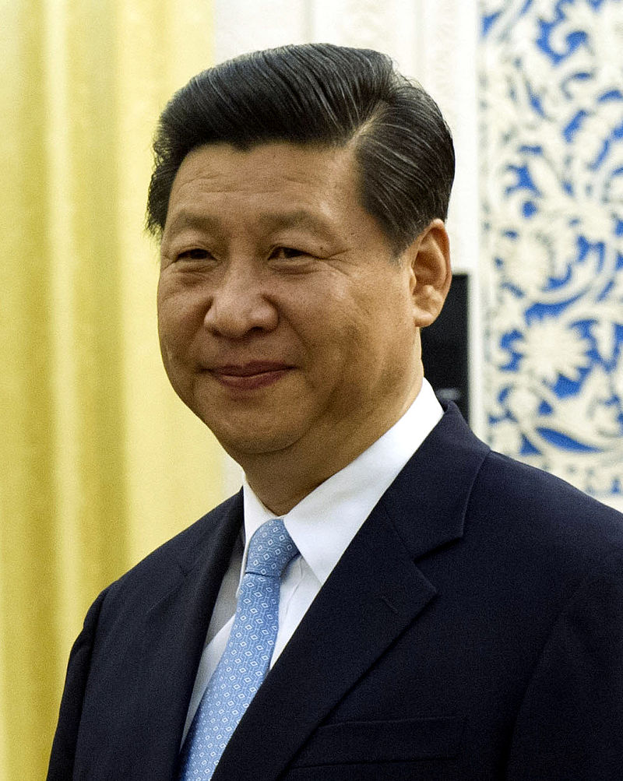

Xi Jinping
President of the People's Republic of China

I. 7. What is the title of this movie?

https://youtu.be/Tfdx9hRVS2g

Basic Instinct

I. 8. Which year was this movie released?

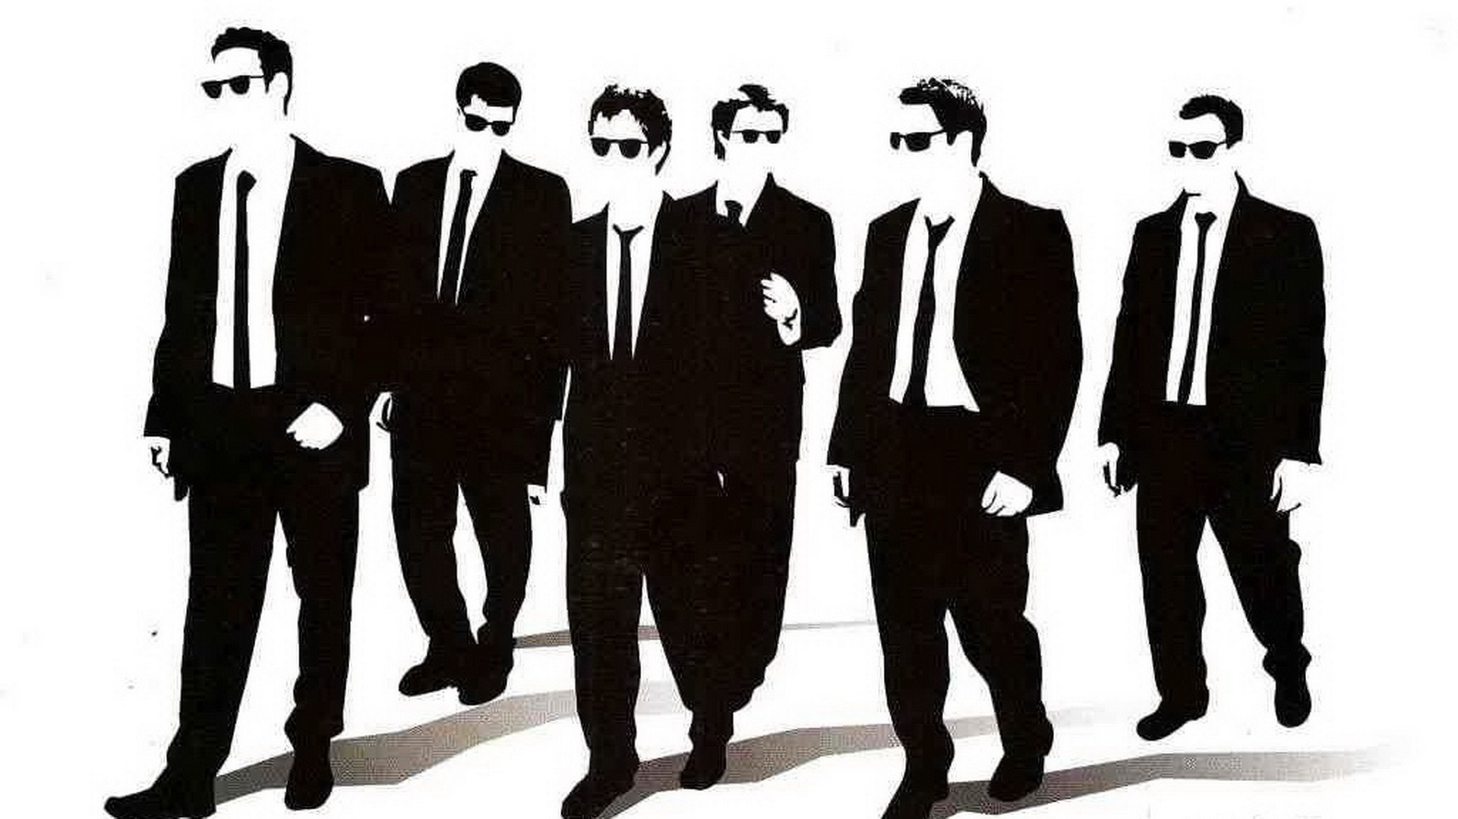

1992

I. 9. Which country has the most nominations for a Oscar in Foreign Language Film?

France

I. 10. Which building took over the title “World’s tallest building” from the Great Pyramid in 1889?
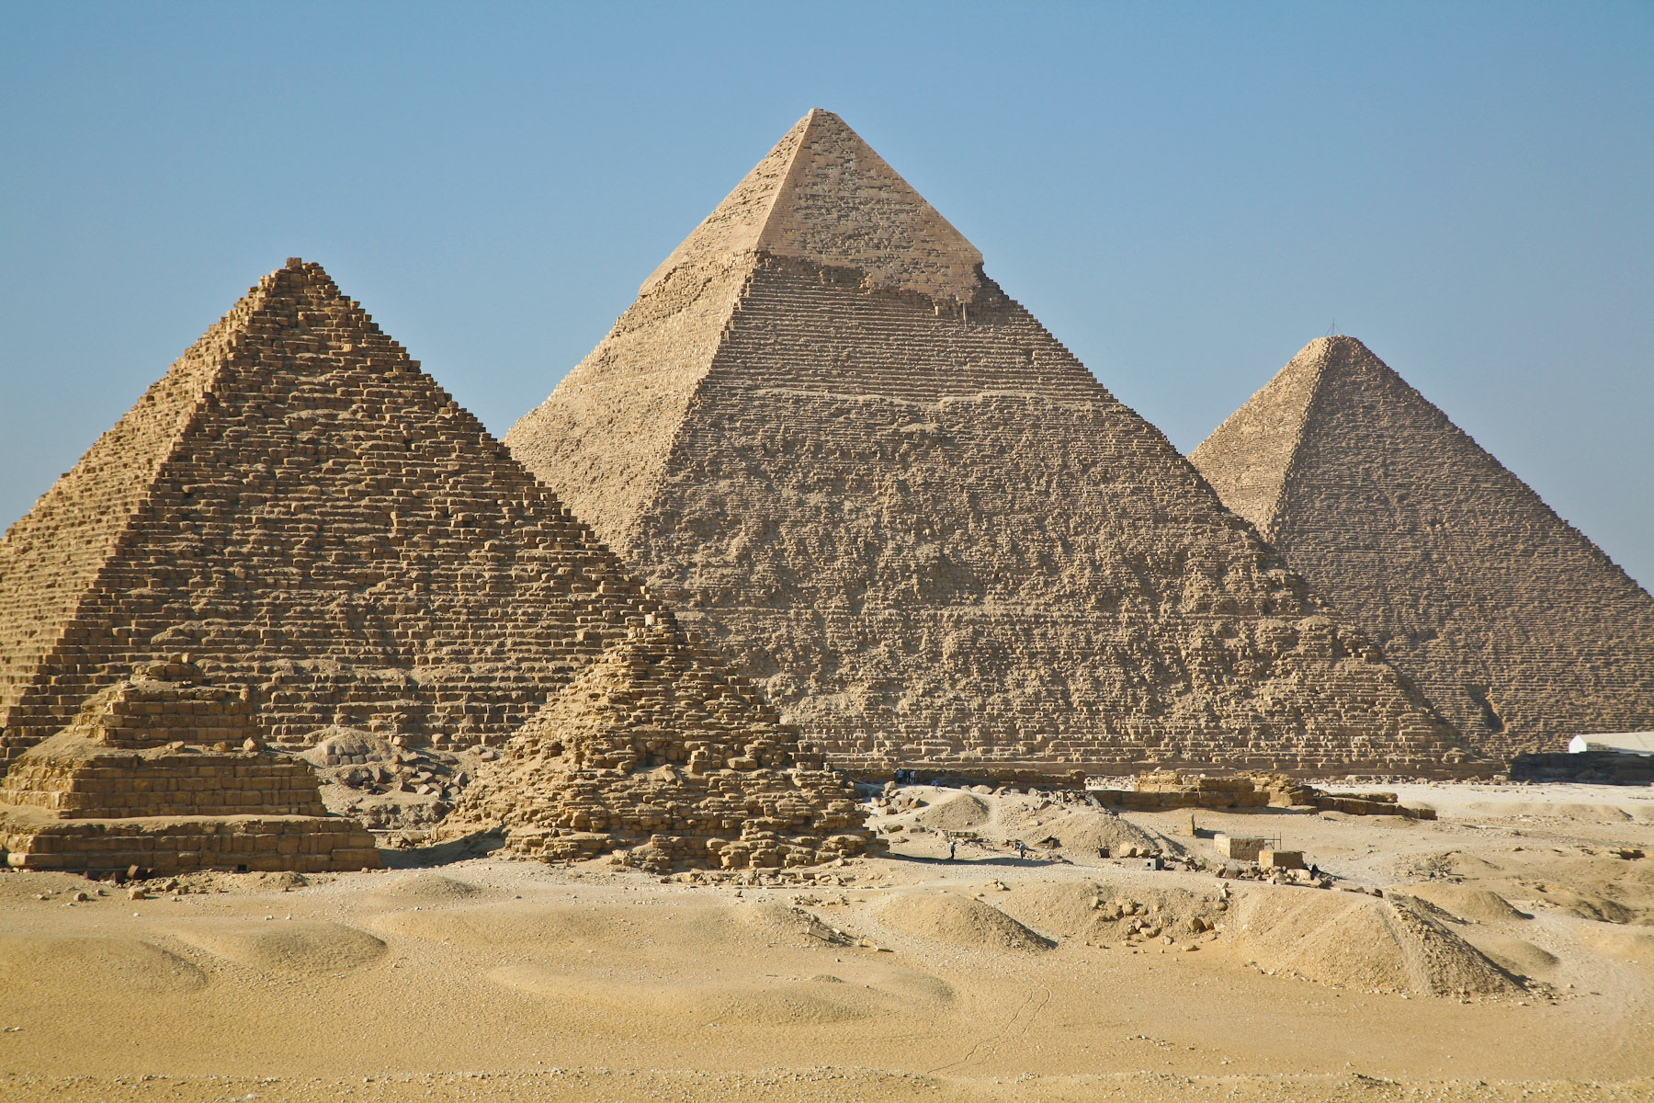
The Eiffel Tower

I. 11. Which country was the Statue of Liberty a gift from, and when?

France, October 28, 1886

I. 12. What is the total length of these nails?

8.65 m (28 ft 4.5 )

I. 13. This summer in Spain's Rototom Sunsplash music festival this singer for playing at the festival. Why was that?

Because it was the festival of peace and he supports the war in İsrael.

I. 14. According to Guınness book of records. where ıs the tallest man lıvıng from?
Turkey

I. 15. Who saıd that?
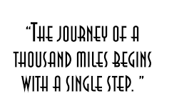
Lao Tzu

I. 16. What is the name of this castle, located in Germany?
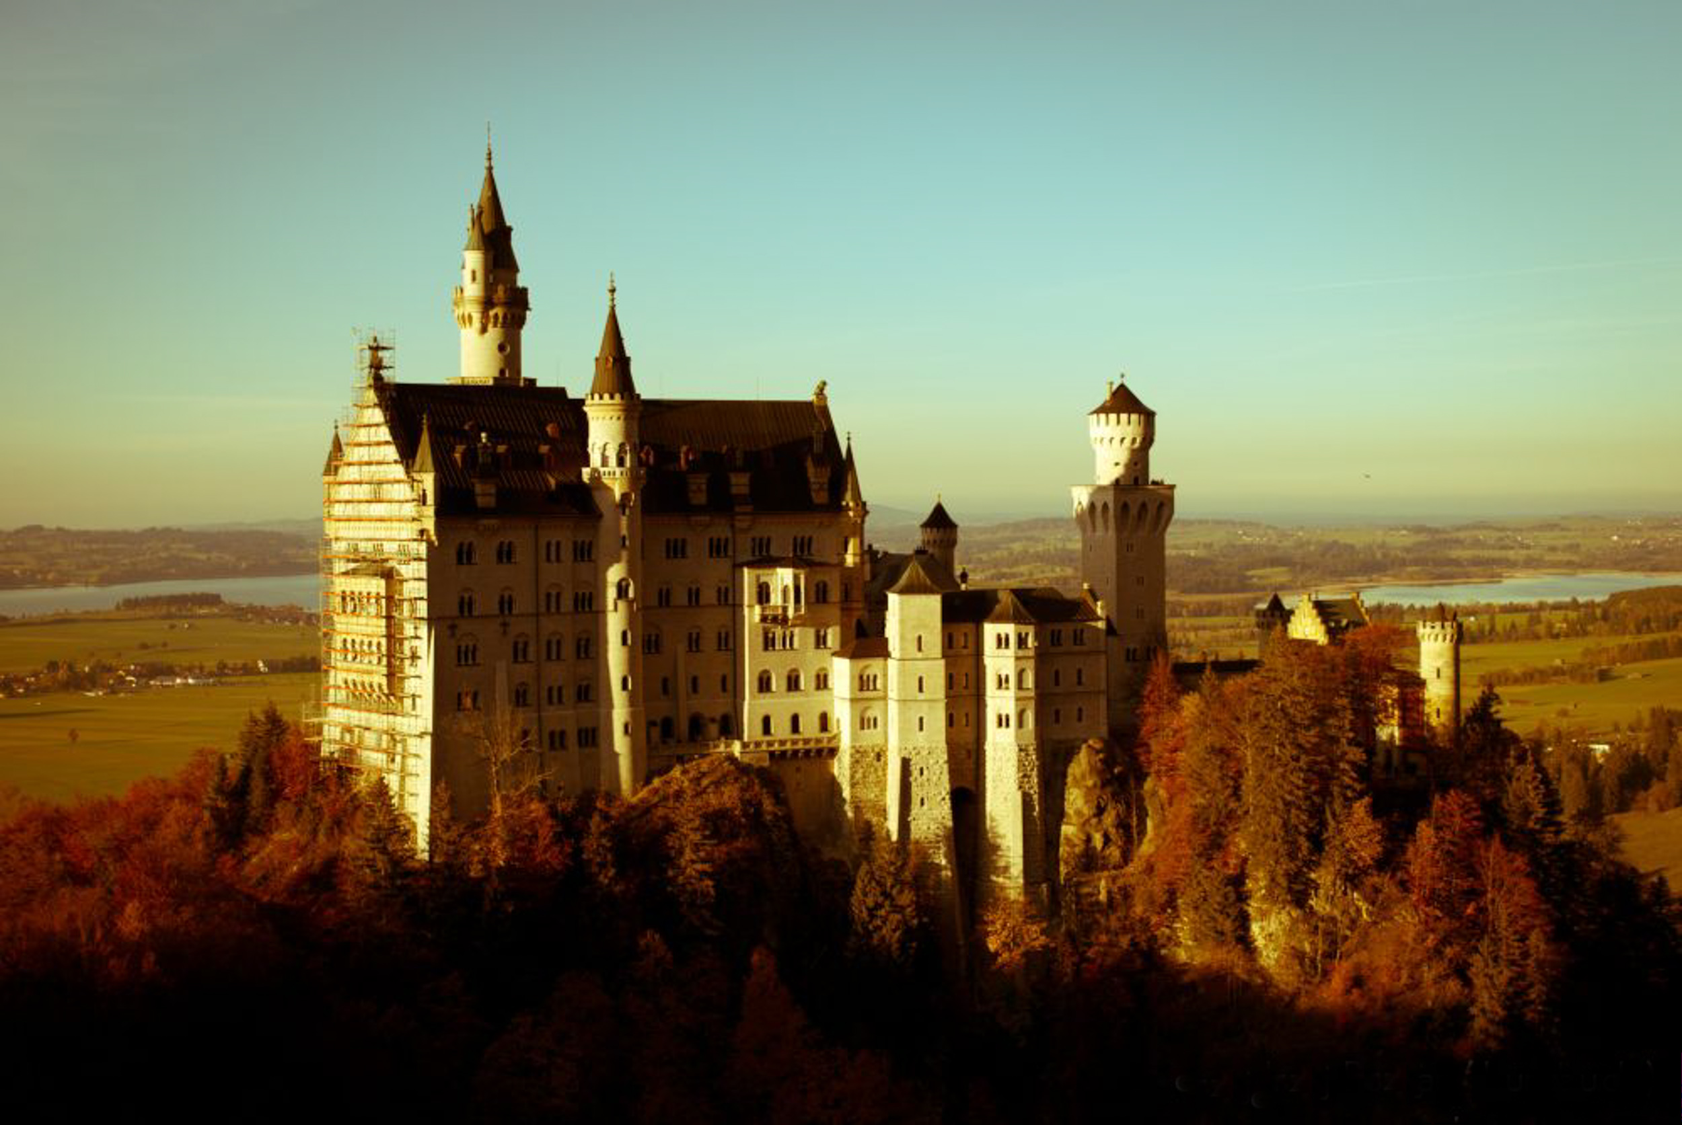

Neuschwanstein Castle

I. 17. In the movie “The Hangover” (2009), which Hotel in Las Vegas did the group stay at?

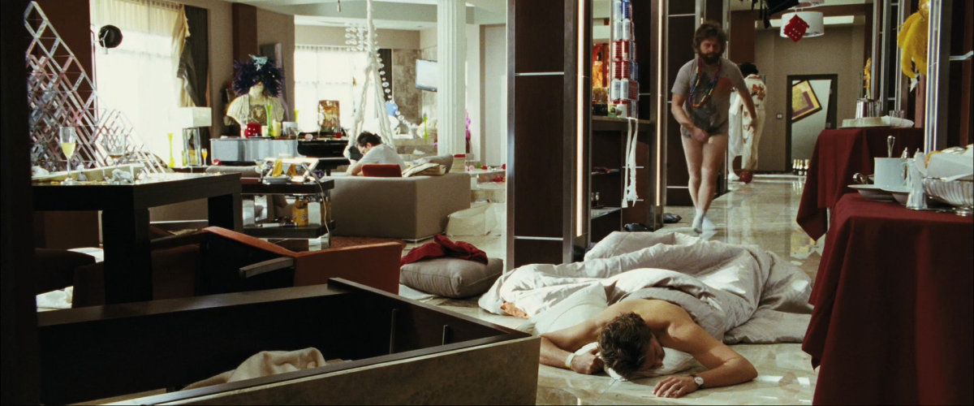

Ceaser Palace

I. 18. What is the name of the boy in the Jungle Book?

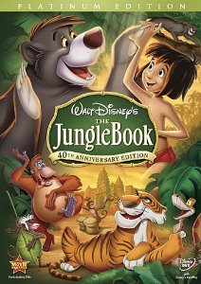

I. 19. What is the largest island in the World?

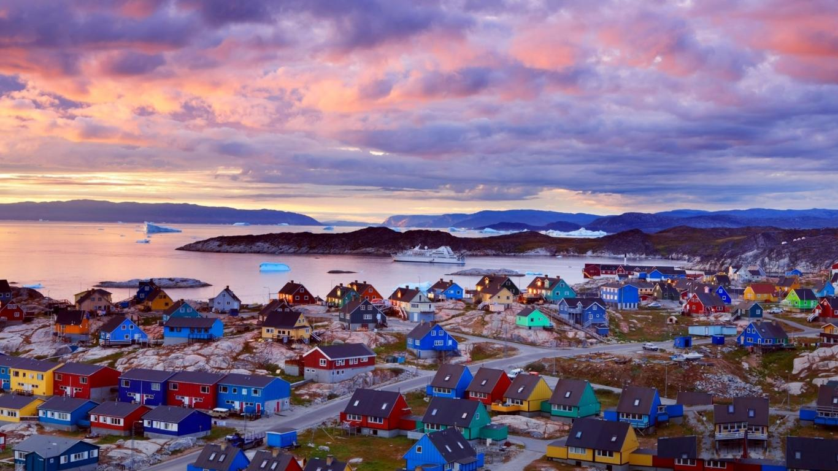

Greenland

I. 20. Who invented Coca-Cola?

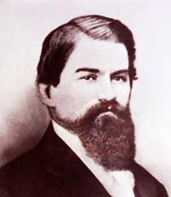

John Pemberton

I. 21. What is the name of the title character in Richard Bach’s famous story?

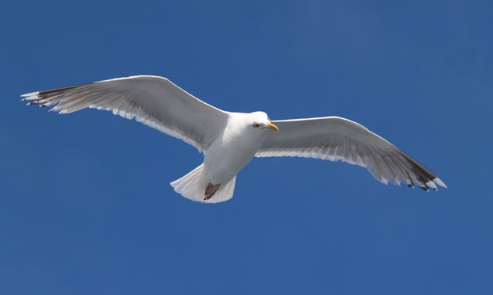
Jonathan Livingston

I. 22. What is the primary religion in Thailand?

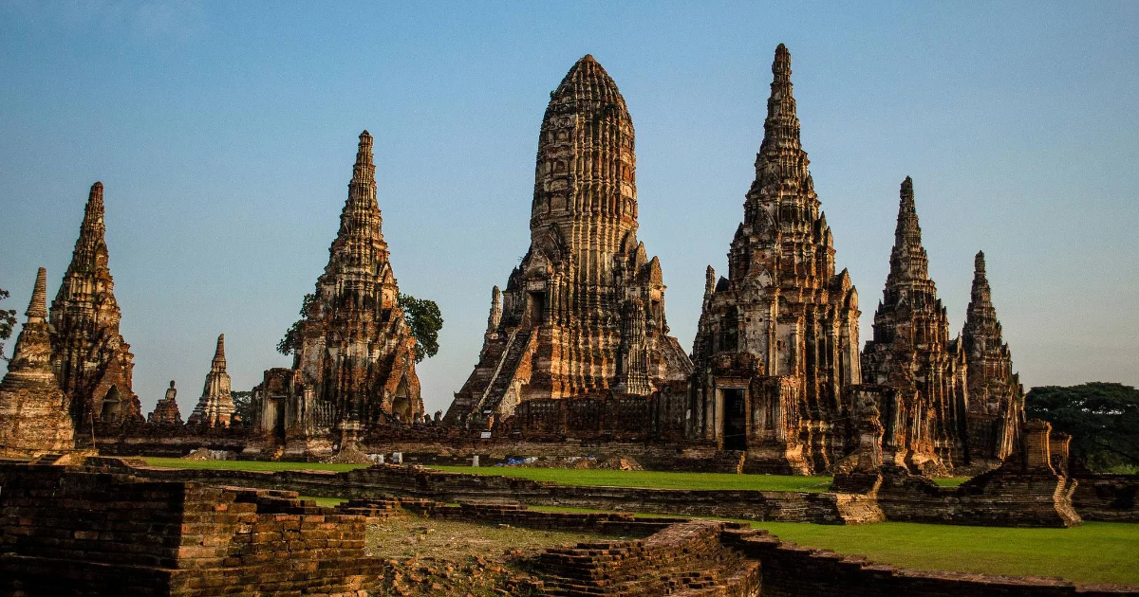
Buddhism

I. 23. What is the last letter of the Greek Alphabet?

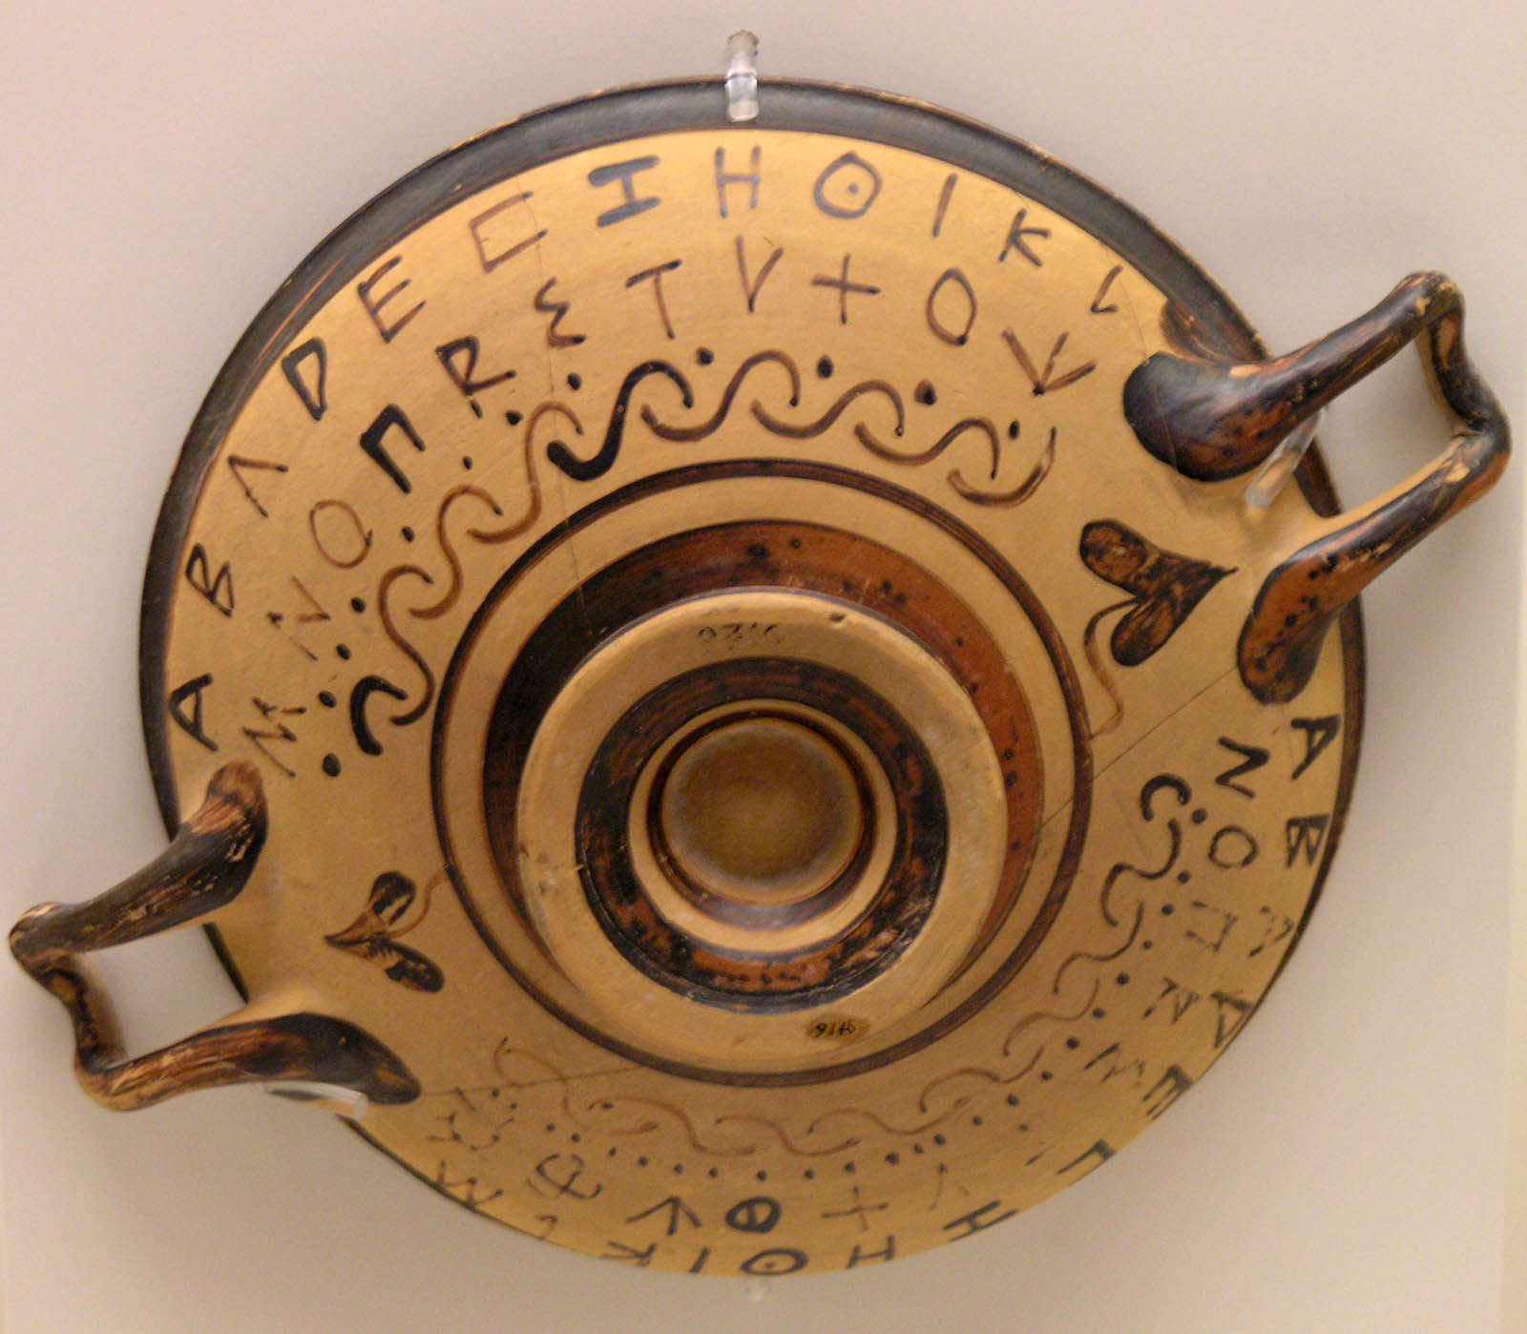

Omega

I. 24. What do the fifty stars on the USA flag represent?

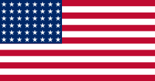

The states

I. 25. How many “Rocky” films did Sylvester Stallone acted in?

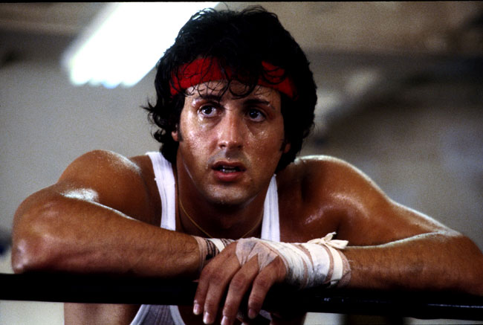

6

I. 26. What is the color of the lipstick actors used in silent movies?

Black

I. 27. What is the maximum age limit to participate in the Olympic Games?
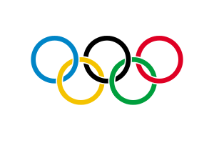
There is no specific age limit for taking part in the Olympic Games. This depends on each International Sports Federation and the rules it lays down for its sport.

I. 28. Which organ secretes the hormone insulin?
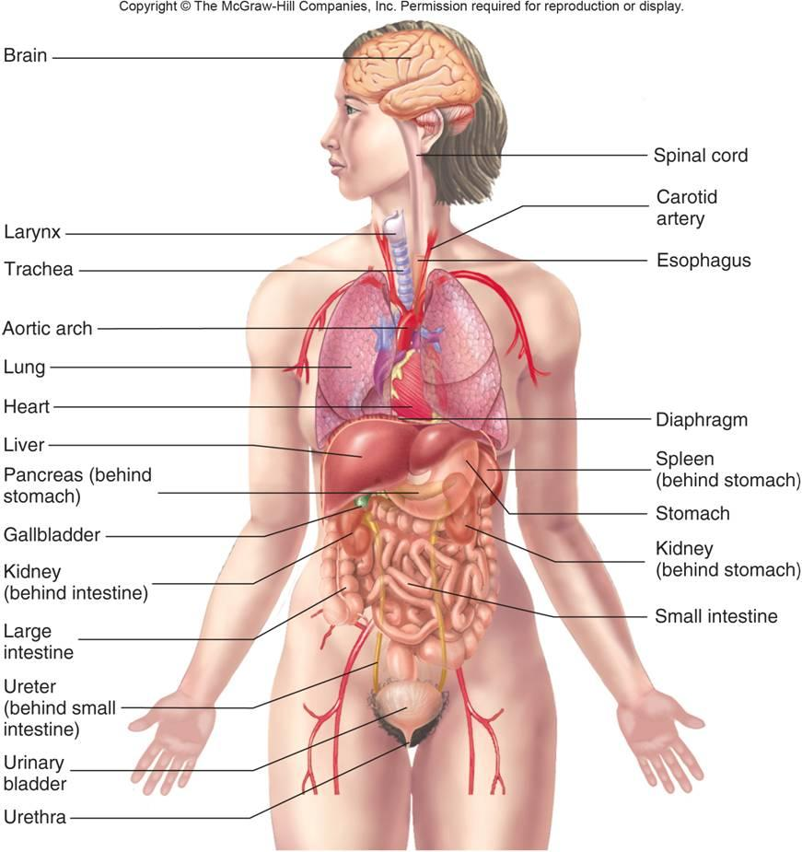
Pancreas

I. 29. What is the world's largest official residence, which is four times bigger than Versailles?
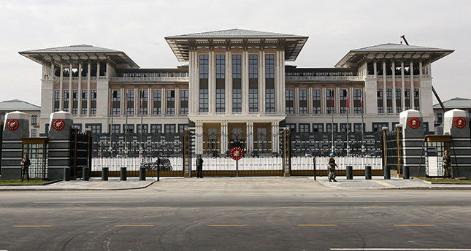

The Cumhurbaşkanlığı Sarayı in the Turkish Republic is the world's largest Presidential Palace, four times that of Versailles.

I. 30. Which of the five senses is developed first?
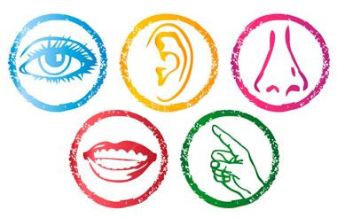
Touch

IN CASE OF TIE...
I. * What athletes shave their entire body to be faster?
Swimmers

I. ** What was the profession of Superman?
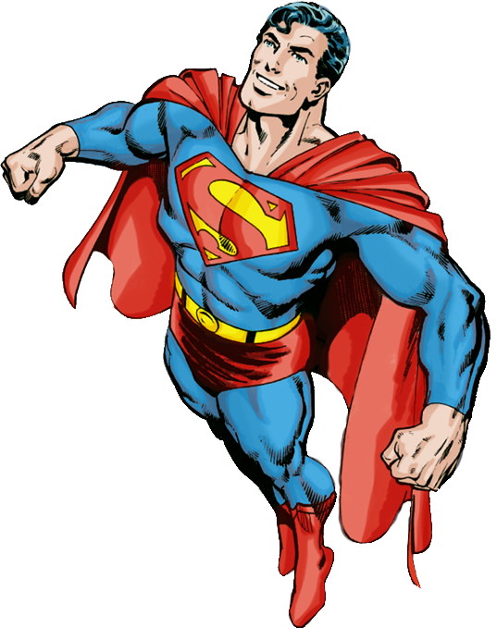

Journalist

