Recycling workshops: TETRAPAK WALLETS
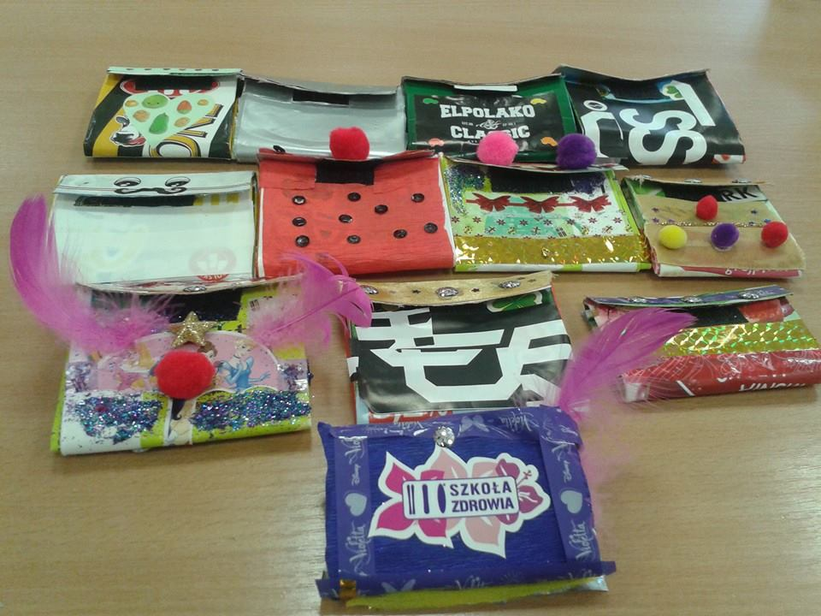
A simple slim wallet made from 1L Tetrapak carton commonly used for milk or juice products - the only things you'll need are scissors or a craft knife, 1L Tetrapak carton, a stapler and some Velcro (fastening tape). If you want to customize your wallet then you can have also, some colour papers, glue, stickers, packing tape…
Rinse well and dry the Tetrapak carton before starting to ensure no residue remains in the carton.
Realise the top and bottom, flatten the Tetrapak and use the scissors to cut out the top and bottom. From the bottom, fold 1/3 of the box and cut the 4 corners of the Tetrapak until the folded line. Cut off the back and side flaps but leave the top flap without cutting. The sides are currently fold out so pack them in and fold the other 1/3 of the box up so it’s touching the middle part, lock them in the middle with a stapler. Stick the self-adhesive (Velcro) tape inside the upper lid and outside the wallet so it can stick together. Now customize it as you wish.
You can also see this video step by step: https://www.youtube.com/watch?v=JIFeRMvNXKA

