**SESIÓN 1**

**GARDEN TALKS (15 minutes)**

We’re going to have a little garden talk to present the school gardening project. This is our time to share whatever we’d like about our gardens, other gardens we see or visit, and vegetables we eat or know about.

Ask the children to share what they know about how plants grow. Most of them will probably be familiar with the basics of plant growth. We put aprezi presentation about it (part of the plant, cares our plants need…)

Once the seed is buried in the earth, it begins to sprout and push up towards the surface. The roots grow first, and they stay underground.

The roots are like the fingers of the plants. They reach out and bring water and nutrients from the soil back to the plants so that the plants can continue to grow.

Water and sunlight are like food for the plants, and plants need both of these things to grow. That’s why we should put our plants by the window, so that they can get lots of sunlight to stay healthy and keep growing.

After 7-10 days the seed sprouts its roots under the soil, and grows up towards the sunlight. When they get big and strong enough, they will push above the surface of the soil, and

then we can watch them growing.

That’s why it’s so important for everyone to grow gardens, just like you are going to do. The more gardens and plants we have growing in the city, the healthier the city will be. Can you think of different places that people grow gardens in the city? have pictures of different places in the presentation:

* In backyard
* In park community gardens
* On roof
* In greenhouses
* On windowsill
* At school!!

**EXAMINATION. VEGETABLE GUESSING GAME (20 minutes)**

TOOLS: mystery vegetables (potato, carrot, onion, garlic, zucchini, aubergine, tomato and pepper), prezi presentation, blindfolds

We explain to the children that they are going to have a chance to examine different kinds of vegetables, and to try to guess what they are and how we eat them. Encourage them to use their senses to smell and touch the vegetables.

We can divide class into four groups and we cover their eyes. We provide each group two vegetables. And we ask them to answer the following questions for each vegetable:

* Do you know which vegetable is it?
* Which colour do you think is it?
* Do you eat the inside, the outside, or both?

Circulate among groups and encourage them, giving them tips or clues if necessary. Give them the answers and a little information about each vegetable.

Ex. This is a zucchini. You can eat the inside and the outside, but it’s usually cooked first. (Cut open to show the inside). This vegetable is used to make delicious sauces for pasta, and sometimes it’s grated up really small and used to make cakes. Show prezi with pictures of the plant.

**TASTING (5 minutes)**

TOOLS: chopping board and knife (or bring it chopped from home)

While discussing mystery vegetables, someone can prepare extra vegetables (that can be eaten raw) for tasting: tomato, cucumber,carrot, radish, celery... Circulate them among the kids.

**SESIÓN 2**

**BRAINSTORM: GARDEN RULES (15 minutes)**

Now that we know a little about what plants need to grow, let’s brainstorm the ways we can best care for our garden. These will be the rules we’ll all follow to make sure our vegetables get everything they need and how to care for the vegetables.

Ask the children if they have any rules they’d like to suggest. Ask them leading questions if necessary: what do you think would happen if someone watered the garden when it wasn’t their turn? Maybe we should have a rule that we can’t water the garden when it’s not our turn to water or that we cannot eat it... Attempt the children to make a list. We can post the how we care for our gardenrules in our garden corner.

**EXPERIMENT: OUR SOIL (10 minutes)**

TOOLS: a tablecloth, two big buckets, soil, natural fertilizer (compost, hummus…), sprayer, water, seeds (lettuce and cherry tomatoes), egg boxes, toilet paper cardboards, newspapers. Optional we could have river sand or silica sand, and vermiculite for the seedbeds.

First of all we have to mix 80% soil and 20% fertilizer. If we have, we can put a handful of sand in the soil to make our seedbeds. Now the children are going to touch the soil so they can feel it in their hands. With a plastic glass/bottle (with some small holes in the bottom made with a small needle) we’re going to make an experiment with the water to show how quickly the soil soaks the water and so our future plants will do the same.

**SEEDBEDS: LETTUCES AND TOMATOES (20 minutes)**

We are going to use recycled materials to make our seedbeds. For lettuce we can use egg boxes and for tomatoes we can use cardboard or newspaper. We explain step by step how to make the seedbeds for lettuce and tomatoes:

* Rip out sheets of newspaper in ⅓
* Fold it a little bit in one side
* Roll it with a toilet paper cupboard
* Close the bottom and take cupboard out

Now we fill our seed beds with soil and we water them. Once again fill them up a little bit more and water them. We make a tiny hole in the middle where we will put our seed. Then we will cover it and sprinkle with vermiculite (if we have some). Its important not to move the seedbed after this so the seed stays where is supposed to.

More or less the lettuces and tomatoes will take 1 month and ½ in seed beds, then we will plant them in pots and wait one month ½ more before eating. We will plant radish between the lettuces.They will be ready by the end of may, beginning of june. Perfect to make a salad!!

10349135_10204570888366985_6323124274815134072_n.jpg

**SESIÓN 3**

**RECYCLING WORKSHOP: MAKING A WALLET FROM AN EMPTY TETRAPACK**

19111_10204570889567015_1362325405174002428_n.jpg11074587_10204570888726994_5583785937056453791_n.jpg

**SESIÓN 4**

**EARTH GYMKHANA**

**SESIÓN 5**

**KNOWING EACH OTHER A LITTLE BIT BETTER**

1. BINGO: Find someone that…

|  |  |  |  |  |
| --- | --- | --- | --- | --- |
| **WAS BORN THE SAME MONTH AS YOU** | **DOESN’T LIKE CHOCOLATE** | **HAS A PET AT HOME** |  | **COLLECT SOMETHING** |
| **HAS TRAVELLED TO ANOTHER COUNTRY** |  | **HAS A BIKE** | **PLAYS AN INSTRUMENT** | **DOESN’T LIKE PIEROGI** |
|  | **SPEAKS 3 LANGUAGES** | **LIKES VEGETABLES** | **HAVE A GARDEN AT HOME** | **IS WEARING WHITE SOCKS** |
| **SINGS VERY GOOD** | **USE GLASSES** |  | **LIKES READING** | **DOESN’T HAVE BROTHERS OR SISTERS** |
| **PLAYS SPORTS** | **HAS BROWN EYES** | **KNOWS HOW TO DANCE** | **HAS ANY ALLERGIES** |  |

2) TALK POSITIVE

Children draw a picture of themselves and put the name on top of it. We give each of them some post-it stickers. They have to stand up and leave their picture in their table and have a look around. In the post-its they have to write 1 positive thing about everybody in the class and put it in their pictures. They have to write something to each person so all people get the same amount of positive compliments.

**SESIÓN 6**

Team building games

**SESIÓN 7**

**SPRING MURAL**

Today is a sunny day so we’re going to make a spring mural altogether. First 15 minutes of the class we will go to the school garden and children will pick up flowers, leaves, sticks… things related to nature and spring.

After this we will put together our collection of things and design a big spring mural that can be hanging in the class.

**THE GARDEN OF SPECIAL SPECIES**

If we have time we can also do this activity. Now they have to imagine they are a flower, unique, special as they are. They can choose how their flower looks, draw it, put some color on it and they have to say:

* Name
* 3 characteristics of that flower
* Climate
* Terrain
* When it blooms
* Special cares

This activity can also be done with planets: draw it, put a name, characteristics, how do you live in your planet, what is special about it…

**SESIÓN 8**

Zumba: 5 songs for dancing easy zumba choreography

Baloons game

**SESIÓN 9**

Recycling: making masks from egg containers

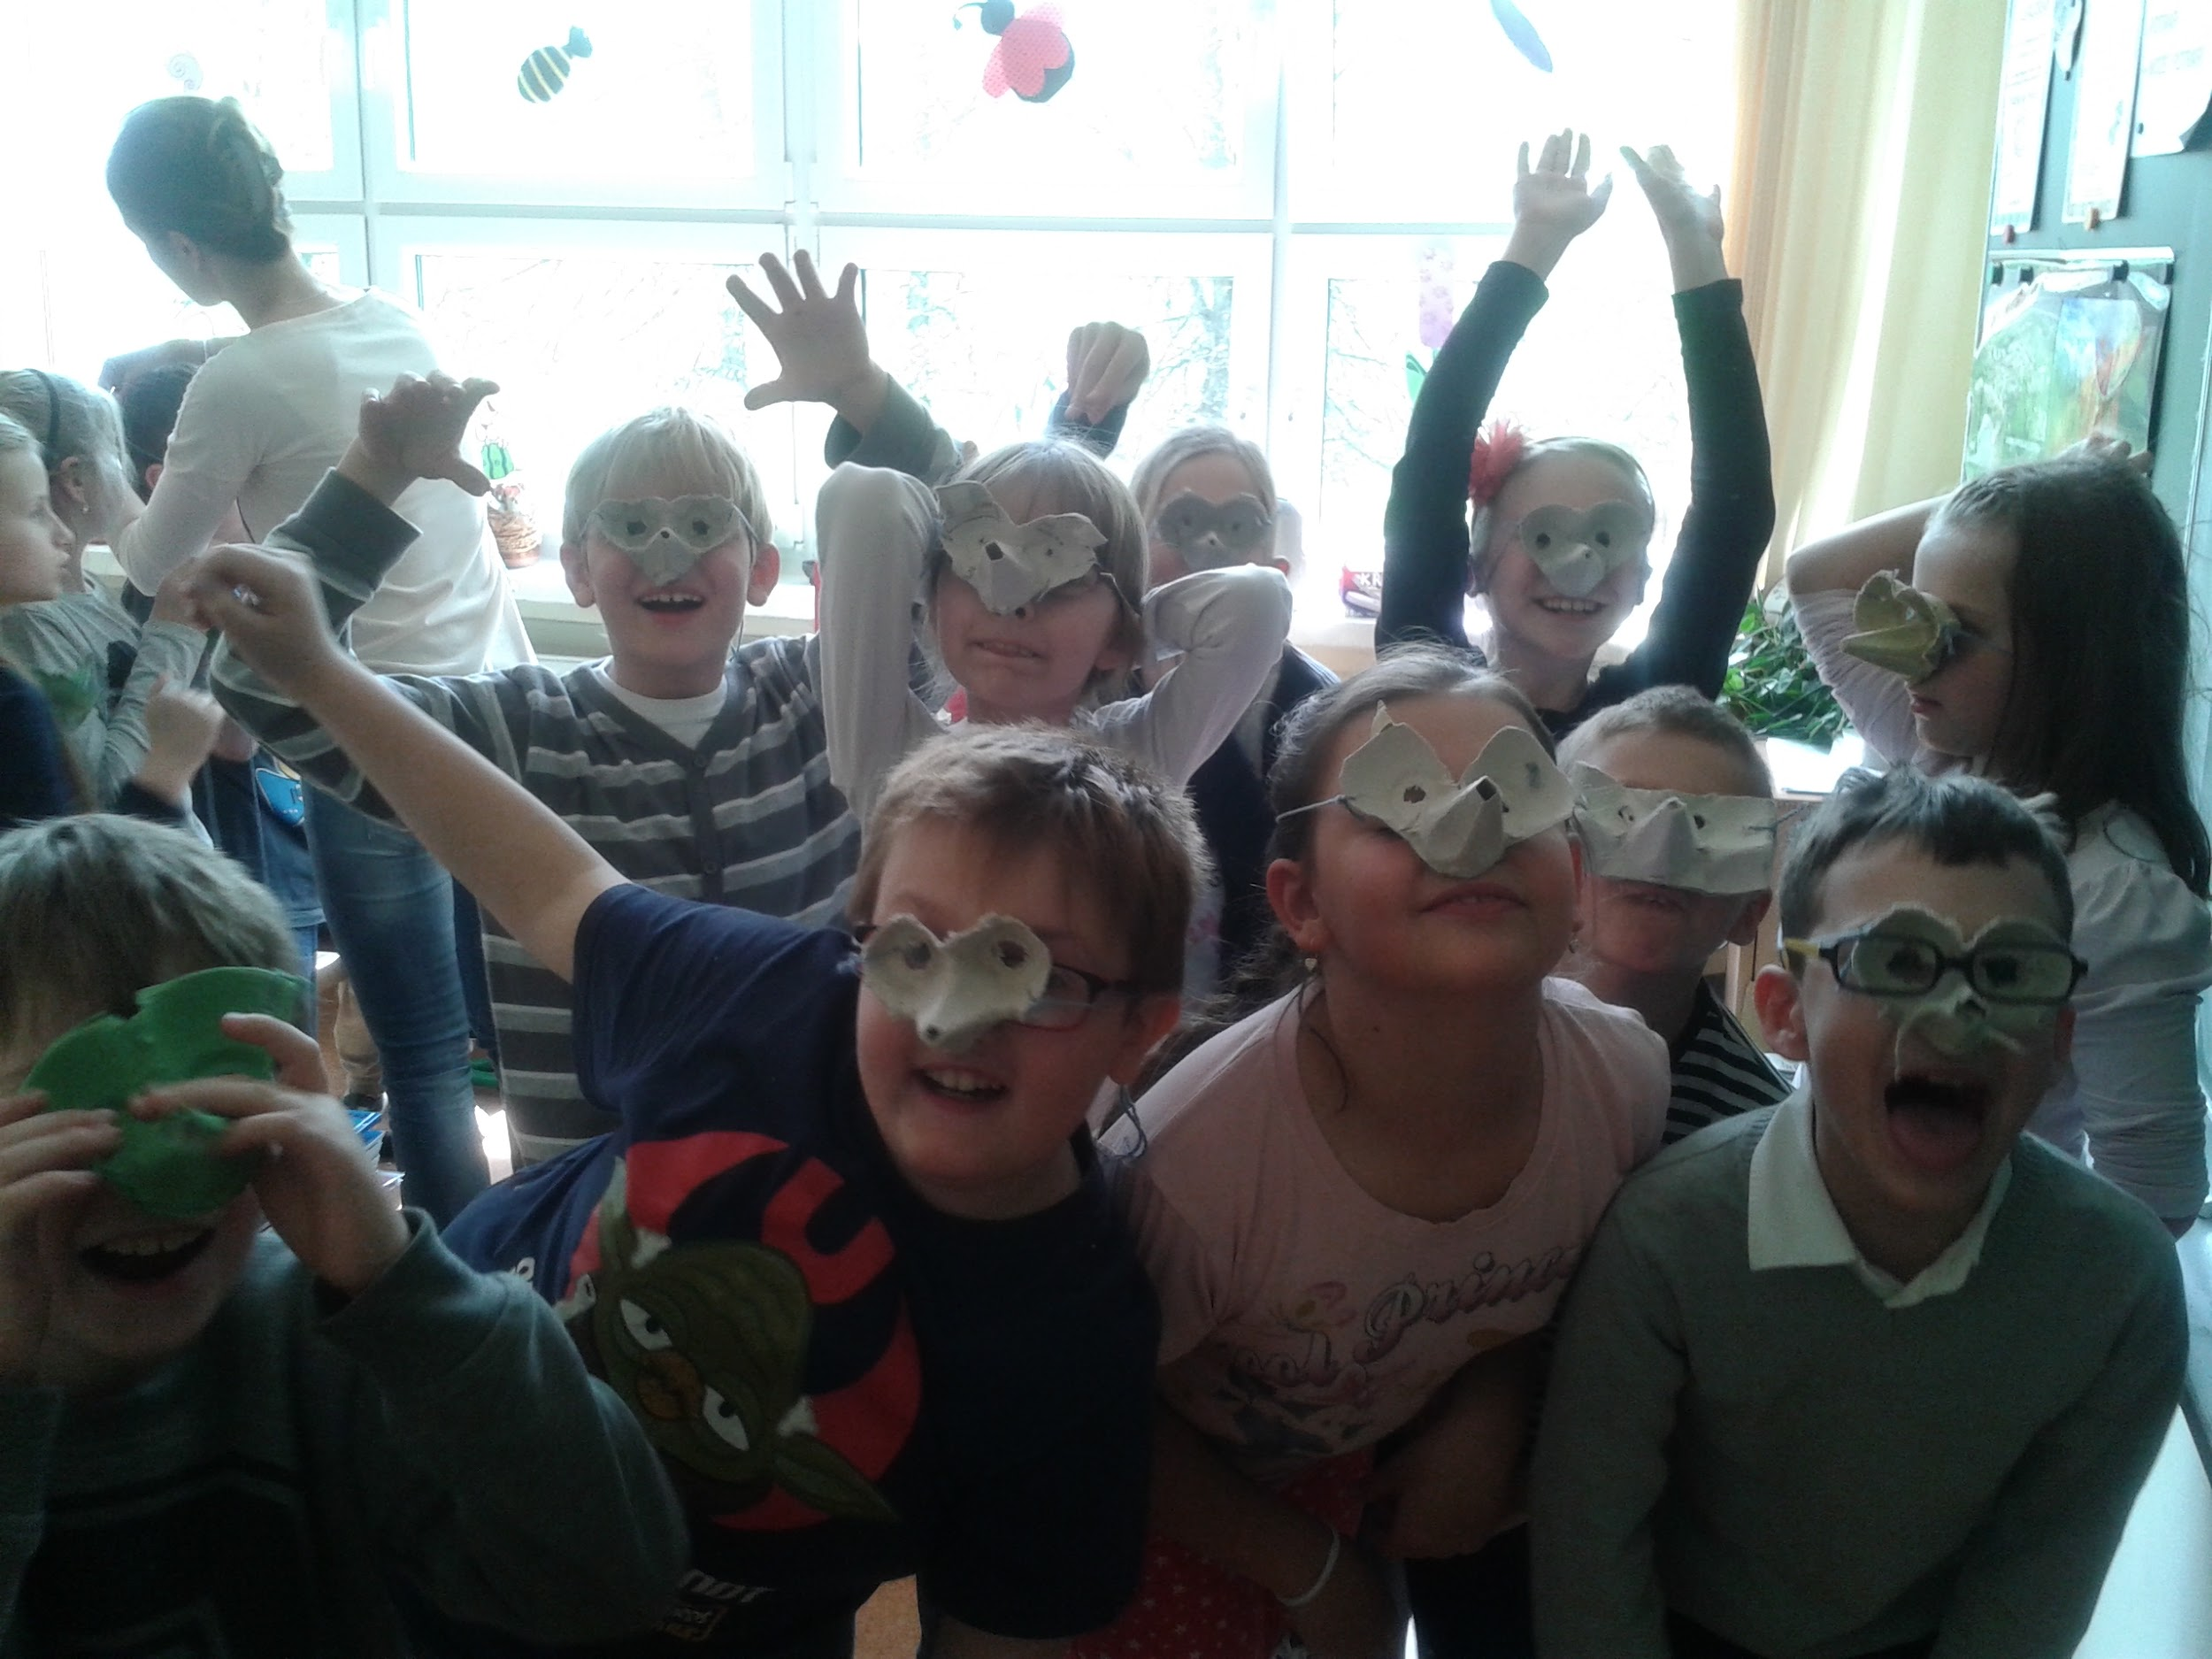

**SESIÓN 10**

Painting mandalas

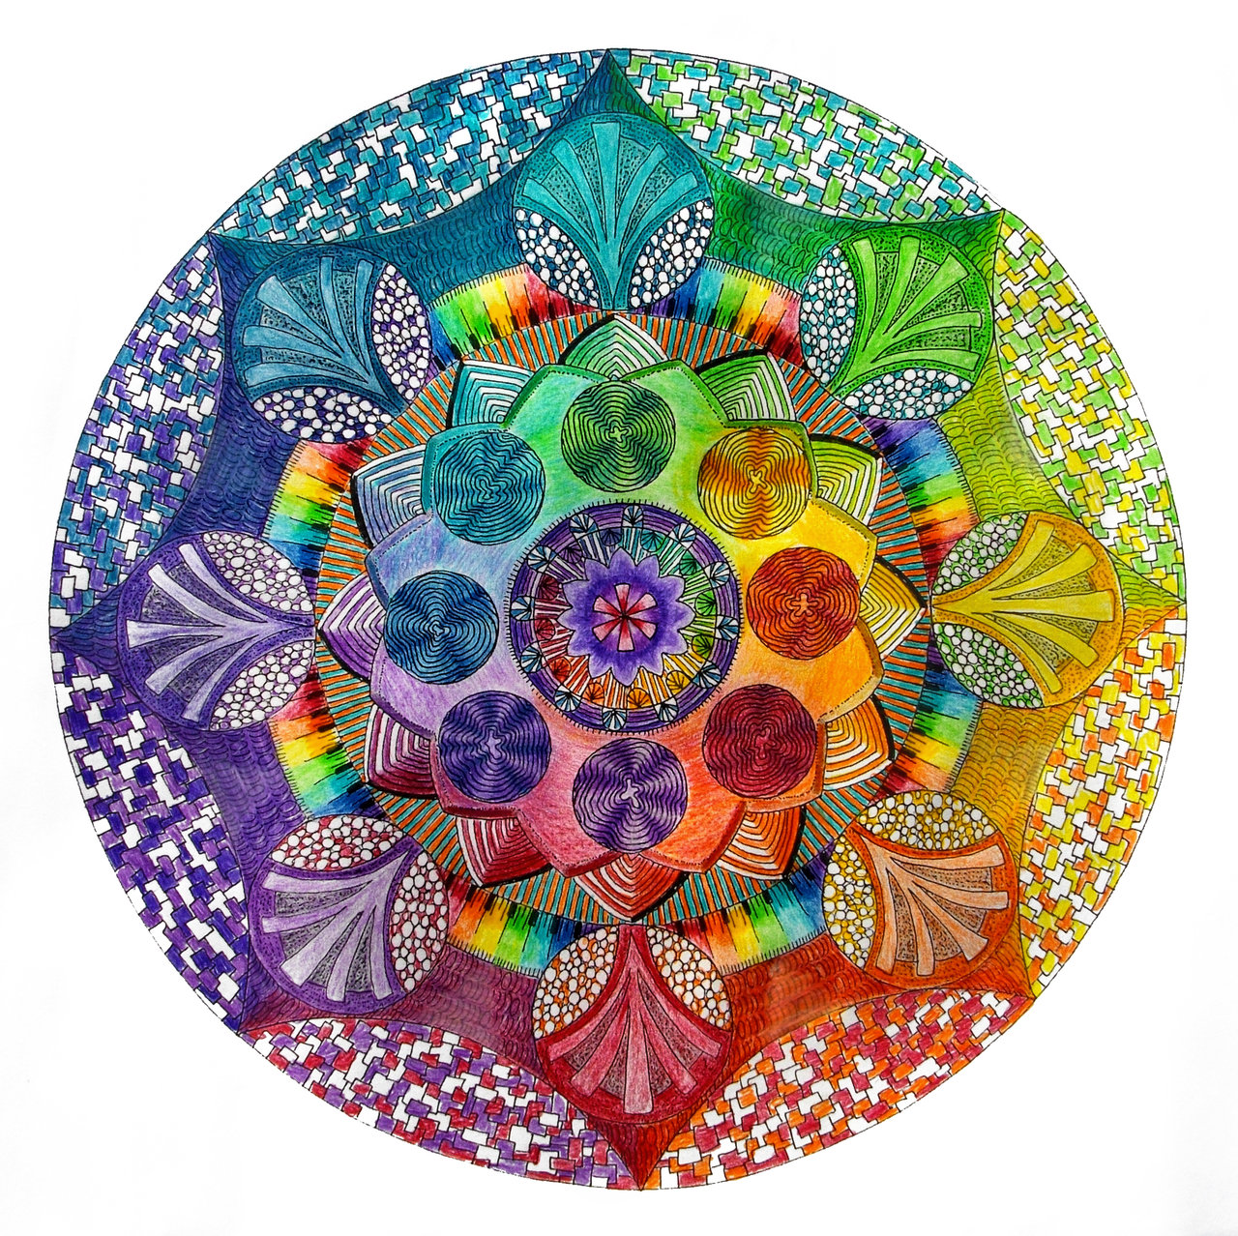

Mandala is a spiritual and ritual symbol in Hinduism and Buddhism, representing the Universe. Mandalas are used as a way of meditation. According to Buddhist scripture, sand mandalas transmit positive energies to the environment and to the people who view them. While constructing a mandala, Buddhist monks chant and meditate to invoke the divine energies of the deities residing within the mandala. A mandala's healing power extends to the whole world even before it is swept up and dispersed into flowing water.

We give mandalas copies to paint.

If the weather is ok we can also paint salt or rice and make a mandala altogether outside.

**SESION 11**

Outside yoga for children

**SESION 12**

Making paper boxes: 1st painting, 2nd cutting, 3rd glue.

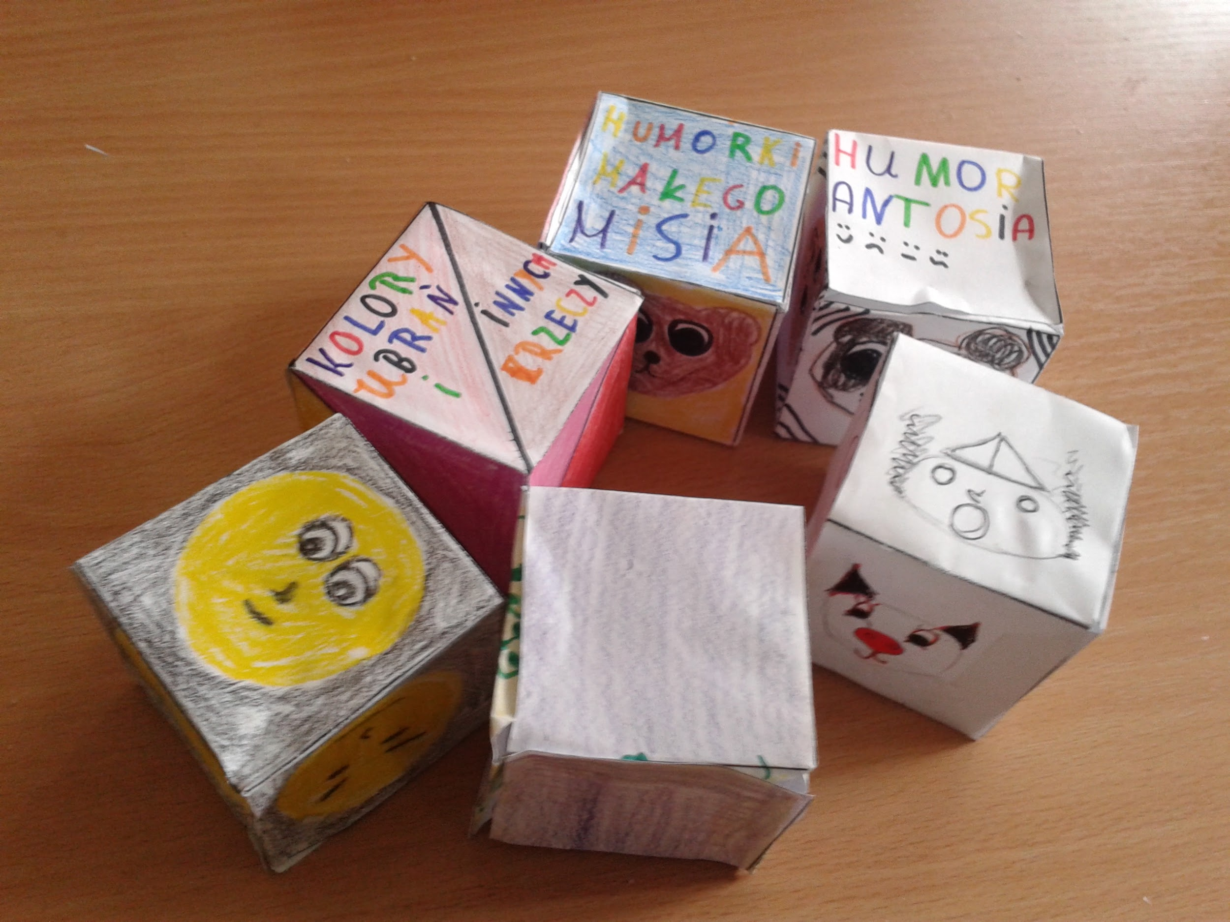

**SESION 13:**

Painting salt and making using old glass containers to make salt decoration

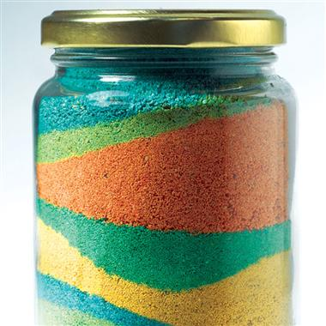

**SESION 14**

Making pyramids, cubes and icosahedrons with sticks and candies (Bea)

**SESION 15**

Dreamcatchers with sticks, leaves and yarn

**SESION 16**

Recycling kites. Newspapers + sticks + glue + thread

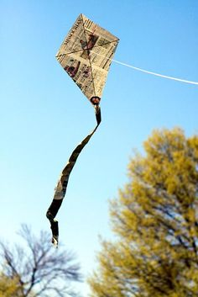

**SESION 17**

Kariokas: baloons + rice + crepe paper + thread

